**Q-3) Ans- Buyer Ratio**

**Anderson Darling Normality Test**

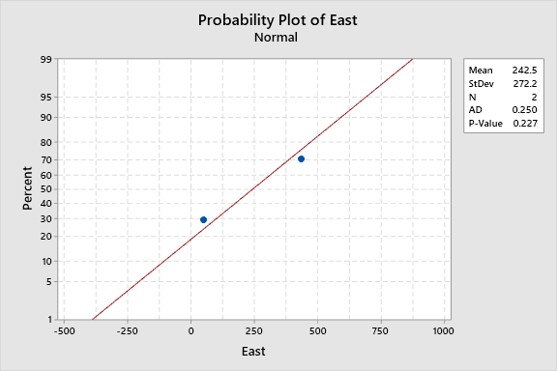

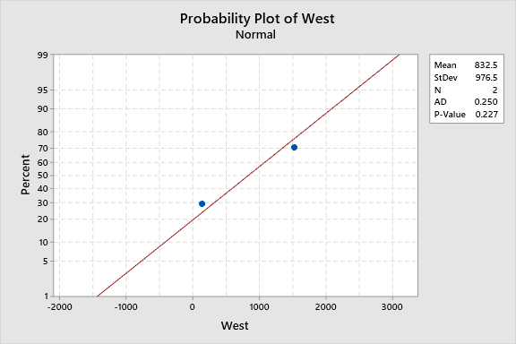

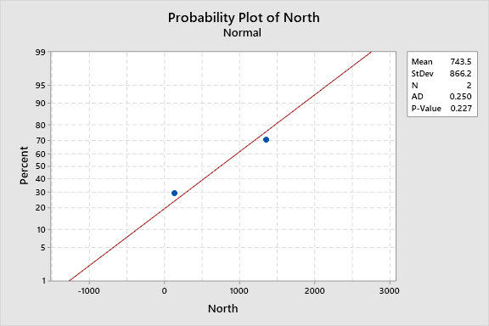

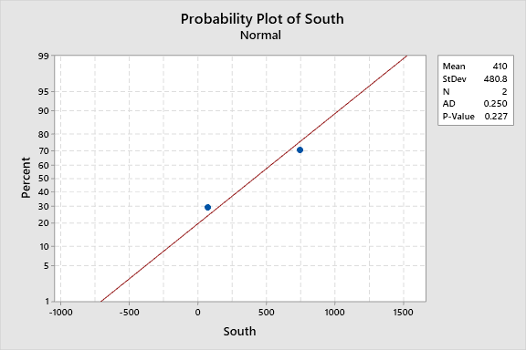

**All are normally distributed**

BUYERRATIO.CSV

**Tabulated Statistics: Worksheet rows, Worksheet columns**

**Rows: Worksheet rows   Columns: Worksheet columns**

|  |  |  |  |  |  |
| --- | --- | --- | --- | --- | --- |
|  | **East** | **West** | **North** | **South** | **All** |
|  |  |  |  |  |  |
| 1 | 50 | 142 | 131 | 70 | 393 |
| 2 | 435 | 1523 | 1356 | 750 | 4064 |
| All | 485 | 1665 | 1487 | 820 | 4457 |

*Cell Contents  
      Count*

**Chi-Square Test**

|  |  |  |  |
| --- | --- | --- | --- |
|  | **Chi-Square** | **DF** | **P-Value** |
| Pearson | 1.596 | 3 | 0.660 |
| Likelihood Ratio | 1.535 | 3 | 0.674 |

**P-value 0.674 > 0.05, so accepting Ho and rejecting Ha**

**Proportion of male-female ratio similar across all region.**